SOFTWARE TESTING

# What is Software Testing?

* Software Testing is the process of evaluating and verifying that a software product or application is functioning right.
* **Software Testing** can be stated as the process of ***Verifying and Validating*** whether a software or application is **bug-free**, **meets the technical requirements** as guided by its design and development, and meets the user requirements effectively and efficiently by handling all the exceptional and boundary cases.
* The process of software Testing aims not only at finding faults in the existing software but also at finding measures to improve the software in terms of ***efficiency, accuracy and usability***.

# Who does Testing?

* Software Tester
* Software Developer
* Project Lead/Manager
* End User

**Difference between Testing and Debugging:**

**Testing:**

* It involves the identification of bug/error/defect in the software without correcting it.

**Debugging:**

* It involves identifying, isolating and fixing the problems/bug. Software Testing can be divided into two steps:
* Verification
* Validation

## Verification:

* It is a process of confirming whether the software meets its requirement or not.
* Process of examining/reviewing of work product.
* Are we building the product right?
* It is a QA activity.

# e.g. Mobile/Email user can able to login – 7-9 days.

# quality for tester or impacts.

* Ask Questions (if possible, prepare the solution also), Provide the feedback.
* No assumptions.

===================================

City:

State:

Country:

Ask question???? Why this is in this order????

Give solutions

Impact - Good efficiency, performance, usability, visibility

=====================================

* It’s a static process performed at compile time.
* Cost and Time effective.
* Activities involved in this are inspections, reviews, walk-through. **Validation:**
* It is a process of confirming whether the software meets user’s requirement or not.
* Process of executing a product and examining how it behaves.
* Are we building the right product?
* It is a QC activity.
* It’s a dynamic process performed at run time.
* It is performed by a QC team.
* Cost and time taking.
* Activities involved in this are testing the application.

**Ex**

**Image 1 –**

**What is strategy test this product, ur view about it? Please elaborate.**

**-Question may be asked like what type of application is it?**

**Importance of Software Testing:**

* Defects can be identified early.
* Improves quality of software
* Increased customer satisfaction
* It helps with scalability.
* Saves time and money.

# What Is Software Testing Life Cycle?

Software Testing Life Cycle is a process used to test software and ensure that quality standards are met. Tests are carried out systematically over several phases. During product development, phases of the STLC may be performed multiple times until a product is deemed suitable for release.

*Common Activities included in STLC are:*

* Analysis of client and stakeholder system requirements.
* Creation of a traceability matrix.
* Identification of testing techniques and types needed for each feature.
* Prioritization of features to be targeted.
* Analysis of how tasks can be automated.
* Identification of environment information.

***STLC Phases:***

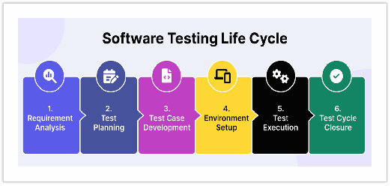

Software Testing Life Cycle contains the following steps:

1. Requirement Analysis
2. Test Plan Creation

Split 1. Test strategy 2. Test plan

1. Test Case Development
2. Test Environment Setup
3. Test case Execution
4. Test Cycle Closure

**Test strategy:**

**Get OTP by email.**

**Get OTP via SMS.**

======================scripted approach for Testing ======================

Diff b/w test case and test plan

Test scenario – verifying the login credentials with valid credentials.

TC:1 : verify the login feature with valid credentials using otp by email.

Steps:

1. Open the browser and enter the url. After entering the url login page should be displayed. -----🡪 pass
2. Enter the email id: [abc@gmail.com](mailto:abc@gmail.com). – user should be able to type the email in the text box. --🡪 pass
3. Enter tge password. Password should be displayed astersk sign. --🡪 pass
4. User click on login button. Login button shoul be clickable --🡪 fail

Expected result : otp should be displayed to user.

Defect Summary / Title : not able to click on login button after providing valid email and password.

Defect description :

URL : https://qa.flipkart.com

* I have tried to provide valid email.
* After provided the password.
* After click on login button, not able to see OTP page.

Status : new --🡪 Assigned (Duplicate, Rejected, Defferred, Not a bug,

Actual Result : not able to see OTP page.

Expected Result : OTP page should be displayed after providing valid user creds.

Proofs: screenshots, screen recordings, logs, console logs.

Env: QA, browser: chrome, OS : windows

Build version/Number : v1

Test Data : credentials

Priority : Urgent, High, medium , low

Severity : Blocker, Crash, major, minor.

Assignee : Developer Team

Label : UI, BE, Broser_issue

Sprint : sprint1

TC:2 : verify the login feature with valid credentials using mobile via SMS.

**Requirement Analysis:**

In this phase, the team reviews the Software Requirement Document (SRD) and other related documents. Identifying any ambiguities in the documents.

In this phase, the Testing team will also analyze whether we can automate the product using the Automation Feasibility Report.

If the score is above 70%, they will go for Automation. Here, the testing team will prepare one report called Requirement Traceability Matrix (RTM) document.

RTM is used to map all your business requirements with the test cases. If any business requirement is missed, we can find it easily with the help of this RTM document.

**Test Planning:**

This phase gets started once the requirement – gathering phase is completed. In this phase, only Test Lead and Manager may be involved. They prepare two documents called ***Test plan*** and ***Test Strategy***.

### Test Strategy:

* It is the High-Level Document which contains the overall approach.
* It varies from organization to organization.
* But inside the organization, it is the same for everyone.

### Test Plan:

* It is a document that contains all the planning activities like scope and features to be tested, objective, what to be tested, cost & time estimation, staffing & training.
* It varies from project to project like identifying the test deliverable and milestones.
* Assigning roles and responsibilities to the testing team.
* Reviewing and approving the test plan.

At the end of this phase, the testing team should have a detailed plan for the testing activities that will be performed. This will help to ensure the testing process is well organized and that the testing team is able to deliver high-quality results.

## Test Case Development*:*

In this phase, the testing team prepares the Test cases and required Test Data for the testing. When the test cases are prepared then they are reviewed by the quality assurance team.

If it is an automation, the testing team have to prepare Test scripts.

The activities that take place during the Test case Development stage is:

* Writing test cases that are clear, concise and easy to understand.
* Creating test data and test scenarios that will be used in the test cases.
* Identifying the expected results for each test case.
* Reviewing and validating the test case.
* Updating the RTM to map requirements to test cases. **Test Environment Setup:**

The necessary hardware, software and network configurations are set up for Test execution. This is an independent activity and can be started along with test case development. In this process, the testing team is not involved, either the developer or the customer creates the testing environment.

## Test Execution:

After the test case development and test environment setup test execution phase gets started.

In this phase, the testing team starts executing test cases based on prepared test cases.

## Defect Logging:

Any defects or issues that are found during the test execution are logged in a defect tracking system, along with details such as severity, priority and description of this issue.

## BUG/Defect Life Cycle:

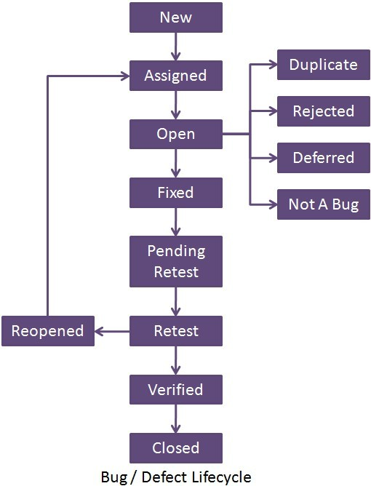

During testing, if tester find any bug/defect, report that to the developer immediately.

The developer will fix the issue and reassign it to the testing team.

Then, the testing team will retest again. So, until all the bugs get closed, we should not close the testing process cycle.

It is important to note that test execution is an iterative process and may need to be repeated multiple times until all identified defects are fixed and the software is deemed fit for release.

## Test Closure:

Test closure is the final stage of the STLC where all testing related activities are completed and documented. The main activities that take place during the test closure stage include:

* Test Summary Report
* Defect Tracking
* Test Environment Clean-up
* Test Closure Report
* Knowledge Transfer
* Feedback and Improvements

### Test Summary Report:

A report is created that summarizes the overall testing process, including the number of test cases executed, the number of defects found and the overall pass/fail rate.

### Defect Tracking:

All defects that were identified during testing are tracked and managed until they are resolved.

### Test Environment Clean-up:

The test environment is cleaned up, and all the test data and test artifacts are archived.

### Test Closure Report:

A report is created that documents all the testing related activities that took place, including the testing objectives, scope, schedule and resources used.

### Knowledge Transfer:

Knowledge about the software and testing process is shared with the rest of the team and any stakeholders who may need to maintain to support the software in the future.

### Feedback and improvements:

Feedback from the testing process is collected and used to improve future testing processes.

## Levels of Testing in Software Testing:

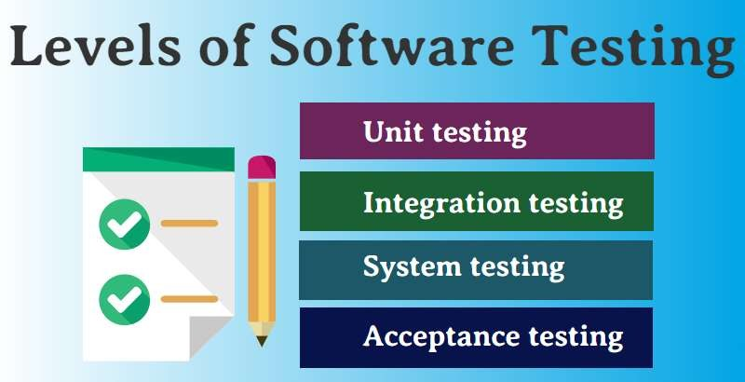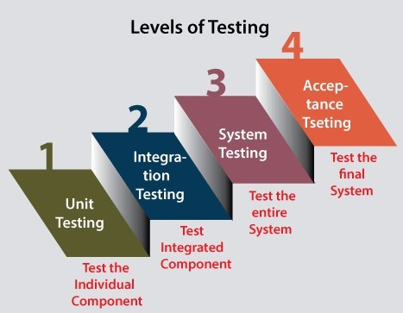

**Unit Testing:**

* A unit is the smallest testable part of any software.
* It is the level of software testing where individual components of a software are tested.
* Unit testing is a White box ***Testing*** technique that is usually performed by the developer.

==========================================

# e.g. Refer Image 2

Unit testing/component Testing

-------------------------------

C = A+B;

2 7

-2 -5 = -7

.22 0

2/3 7/89

null null null is not zero

if ok then pass else it is consider as a bug

SMOKE LEVEL TESTING IN WHICH A HAS SOME VALUE AND BHAS SOME VALUE MAY ME DECIMAL FRACTION ANYTHING.

==================================================

*Unit Testing Tools:*

* JUnit
* NUnit
* JMockIt
* EMMA
* PHPUnit **Integration Testing:**
* It is a level of software Testing where Individual units are combined and tested as a group.
* Integration Testing focuses on checking data communication amongst the modules.

Eg

C = a+b;

C =a*B

=====================================================

*Methodologies of Integration Testing:*

* Big bang Approach
* Incremental Approach **System Testing:**
* It is a level of software Testing where a complete and integrated software is tested. The purpose of the test is to evaluate the system’s compliance with specified requirements.
* It falls under ***The Black Box Testing*** category of Software Testing.
* It is the third level of testing performed after Integration Testing and before Acceptance Testing.

## Acceptance Testing:

* It is a level of the software Testing process where a system is tested for acceptability.
* Internal Acceptance Testing, known as **Alpha Testing,** is performed by members of the organization. Usually, it is done by the members of Product Management, Sales and Customer Support.

E.g. client + internal testing team ---🡪 doctor device , more important.

* User Acceptance Testing, known as **Beta Testing,** is performed by the end users of the software. They can be the customers themselves or the customers’ customers.

E.g --🡪 game , something less important

## Regression Testing:

* After enhancements in the application, testing is done to ensure that the existing functionality of the application is working fine.

## Retesting:

* It is running the previously failed test cases again on the new software to verify whether the defects posted earlier are fixed or not.

## Smoke Testing:

* Build Verification test done to ensure the major functionalities of the application are working fine**.**

## Sanity Testing:

* It is done to ensure that the addressed scope of the release is tested and the same works fine.

## Exploratory Testing:

* It is done with the experience of the tester to explore the application to understand the functionality and find the defects. This is done without formal documentation.

## Secure Testing:

* It is done to check how the application is secure from internal and external threats like viruses, malicious programs.

## Types Of Testing:

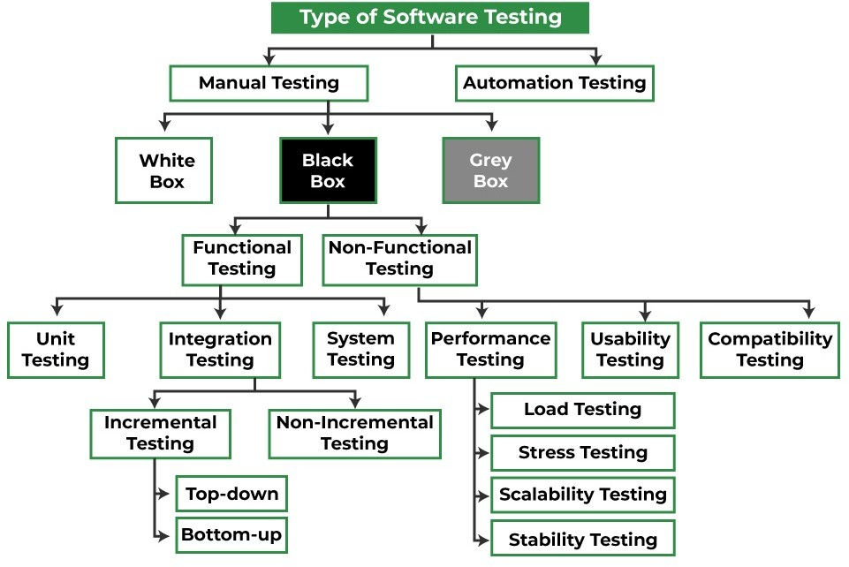

**Manual Testing**:

It is a kind of software Testing in which a Software tester develops and executes the test cases without using any automated testing tools.

Types:

## White Box Testing:

* It is done by developers.
* This testing is focused on Internal Structure and logic of the code.
* Structural Based Technique.
* They are also called Glass box testing.

## Black Box Testing:

* It is done by testers.
* This testing focuses only on what kind of Inputs we are giving. And it checks whether the output meets the requirements.
* This is a specification-based technique.

## Gray Box Testing:

* It is a combination of white-box testing and black-box testing.
* The aim of this testing is to search for defects, if any due to improper structure or improper usage of application.

## Non- Functional Testing:

* **Performance Testing:**
* Testing the performance of an application by providing some workload (number of users).

## Load Testing:

* If workload is between the limits.

## Stress Testing:

* If the workload is beyond the limits.

## Compatibility Testing:

* Testing the app whether it works on different OS, devices, different browsers and its versions.

## Usability Testing:

* It is done to test whether the application is user-friendly.

## Scalability Testing:

* If the number of users is to the maximum limit, to test the system is not getting crash or not.

## Stability Testing:

o To test the application is stable or not, when we give the maximum workload.

## Automation Testing:

* It is the application of software tools to automate a human-driven manual process of reviewing and validating a software product.
* It is used to reduce the testing efforts, also testing faster delivery capability.

A U ĪH O R M A R I Y A M M A L S